# **Job Pipeline Enrichment - Discussion**

*🔹**Requirements*

1. **Enrich Tasks**:
   * Identify and add new tasks to existing megaskills and microskills.
   * Ensure that added tasks contribute to refining the definition of existing megaskills.
2. **Detect Orphan Tasks**:
   * Discover tasks that don’t fit existing skill categories.
   * Group such tasks to create new micro or mega skills under current job categories.
3. **Pass Relevant Trend Data to Skill Trends Page**:
   * Include demand signals, trending skills, and task volume frequency.
4. **Handle New Job Categories**:
   * When encountering tasks from new disciplines, route through a new enrichment pipeline.

## *Job Posting Pipeline:*

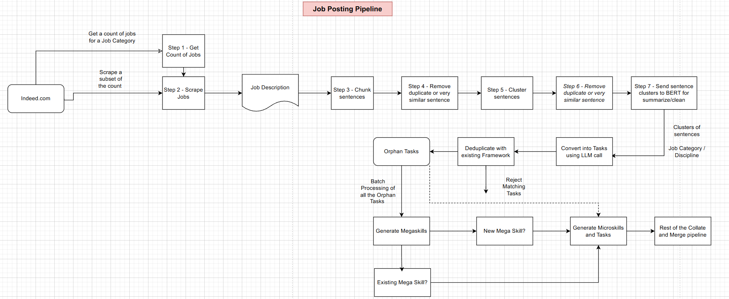

## *🔹 Process to be Followed :*

**1. Preparation for Scraping**

* Set up scraping logic based on:
  + **Option A**: Use a random sample of job postings, calculate sampling percentages, and feed this as input.
  + **Option B**: Define scrape criteria via discussion and build scraping rules accordingly.

**2. Scraping Job Descriptions**

* Extract multiple job postings from relevant platforms.
* Store them in a structured format (e.g., JSON with role, description, source, timestamp).

**3. Task Extraction**

* Use **regex patterns or heuristics** to extract **task-like phrases** from descriptions.
* Normalize and clean phrases (e.g., remove auxiliary verbs, duplicates, general noise).

**4. Clustering of Tasks**

* Embed task phrases using a sentence embedding model.
* Cluster using algorithms like HDBSCAN or K-Means.
* Remove intra-cluster duplicates and near-duplicates (cosine similarity thresholding).

**5. Summarization & Standardization**

* For each cluster:
  + Run a **single LLM call** to clean, summarize, and suggest a **standard task label**.
  + Map task phrases to **internal framework language** (consistent phrasing and structure).

**6. Skill Alignment**

* Map each cleaned task to:
  + Existing microskill/megaskill (if aligned).
  + If not aligned, flag as **orphan task** for potential skill creation.

**7. Orphan Skill Pipeline**

* Send flagged orphan tasks through a secondary process:
  + Validate if they reflect a **new microskill or megaskill**.
  + Propose new skill entries with sample tasks.
  + Record job categories they originate from.

**8. Skill Trends Update**

* Aggregate and pass relevant statistics to the Skill Trends page:
  + Task demand by frequency.
  + Newly aligned or trending skills.
  + Category-wise distribution.

**9. New Job Category Identification**

* If clusters or tasks strongly deviate from current job categories:
  + Propose a **new job category pipeline**.
  + Route new tasks into this pipeline for parallel enrichment and skill definition.

**🔹 Expected Output**

1. A **refined and enriched skill-task dataset**:
   * Tasks aligned to existing micro/mega skills.
   * New microskills/megaskills proposed where necessary.
2. A list of **orphan tasks**, either flagged for review or categorized under a proposed new skill group.
3. **Cluster summaries** of task groups, converted into clean, standardized language matching internal frameworks.
4. Updates or additions to:
   * **Skill Trends page**: showing in-demand or rising tasks/skills.
   * **Job Category taxonomies**: identifying emerging domains or roles.

**🔄 Job Pipeline Flow Breakdown of task and effort**

1. **Scraping Jobs - Divyashree - 16hours (it will be more , will update after discussing with bharath)**
   * Use Indeed (or similar) to scrape job listings.
   * Instead of scraping by absolute numbers, aim for **stratified sampling** (percent-based extraction).
   * Pipeline must serve dual purposes:
     + Updating the internal **skill framework**
     + Tracking **emerging job trends**
2. **Preprocessing (Step 3) – 8h - Kethan**
   * Break down each job description into **sentences**.
   * Apply **regex heuristics** to extract skill-related sentences—mainly those in "Requirements" sections.
   * This reduces noise and narrows focus to potentially relevant skill sentences.
3. **Sentence Deduplication (Step 4) – 2days –** (to make it modular / reusable the effort required is 2days , use database(Vector) instead of filesystem)  **- Kethan**
   * **Embed each sentence** (e.g., via Open AI’s embedding’s).
   * Identify and remove **duplicate/near-duplicate** sentences ( ≥ 90% similarity).
4. **Clustering Sentences (Step 5) – 3days** 
   * Cluster deduped sentences using semantic similarity models (e.g., DBSCAN, K-means).
   * Aim to find coherent groups of sentences representing specific skills.
5. **Cluster Deduplication (Step 6) (Dependent on 3, once 3 is done it takes very less time of about half hour) - Kethan**
   * Review clusters for redundancy or poor separation.
   * Optionally refine or reduce clusters based on similarity.
6. **Cluster Summarization (Step 7) – 2 days - Kethan**
   * Create concise **summaries or personas** for each cluster.
   * Use a local summarization model (e.g., BERT-based) or a lightweight LLM.
   * Represent clusters via either summarized text or representative sentences.
7. **Task Generation & De‑duplication – 2days - Kethan**
   * Send summarized cluster info to an LLM to **generate tasks** (skill-related actions).
   * Embed generated tasks and compare against existing framework tasks.
   * **Reject** tasks that already exist; remaining are marked as **orphan tasks**.
8. **Skill Pipeline Ingestion – 1day - Kethan**
   * Feed orphan tasks through the existing **collate pipeline** to generate **micro-skills** and **mega-skills**.
   * Maintain **contextual linkage**—ensure orphan tasks are traceable even if subsumed under existing skills.
   * Deduplicate new skills before ingesting into the **Neo4j** graph database.

**🔄 Process Characteristics**

* The pipeline is **modular and parallelizable**:
  + Multiple team members can work simultaneously on different steps.
  + Regular **short check-ins (15–20 minutes daily)** are recommended for alignment and iteration.
* Emphasis on **active documentation**:
  + Divya to maintain a **living process document** capturing steps, decisions, and refinements.
  + This ensures clarity and continuity even if some members miss meetings.

**🎯 Next Steps**

* Finalize **process documentation**, define responsibilities, and assign tasks for the week.
* Begin pipeline implementation in parallel streamlines – scraping, chunking, embedding, cluster analysis, etc.
* Schedule daily syncs to track progress and incorporate learnings.

**✅ Outcome**

A structured, multi-step workflow designed to transform job listings into actionable skill-tasks and ultimately feed them into your skill framework and graph database—with a robust documentation-driven iteration process.